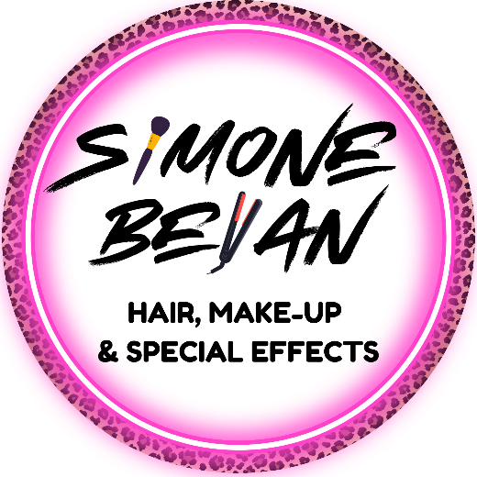
About Me
Simone Bevan
Hair, Make-up and Special Effects Artist

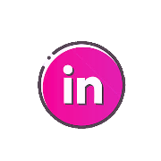
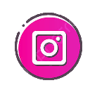
I am a hardworking and adaptable University of South Wales graduate, returning to education as a mature student. With over six years’ experience running a freelance make-up business, I possess strong skills in communication, attention to detail and a proven ability to thrive both independently and within a team. I am now focused on building a career within the TV and film industry.
Contact
Simonebevan@gmail.com
07903096396
www.simonebevan.com

Skills
- Fluent Welsh Speaking
- Full UK Driving License
- Wig styling and application
- Airbrushing & Body painting
- Afro and textured hair styling
- Casualty effects
- Sculpting, moulding, casting and applying prosthetics
- Period hair & make-up
- Life casting
- Knotting & weaving
- Bridal & Special Occasion hair & Make-up
Simone Bevan Make-up
Simonebevanmakeup
Simone Bevan
Work Experience
The Chameleon Effect – Bravado Feature Film
Make-up & hair artist (UK Crew)
Edge21 Studio – Sara Davies Music Video’s – Anfonaf Angel, Just like the movies, Dal yn Dynn
Key Make-up & hair artist
Work Experience - Buffoon Media – Cyfarthfa Museum Exhibition
Make-up & hair artist
Brave Arts Theatre Company – Rapunzel
Make-up artist
Carmarthen School of Art – End of year graduate show
Make-up artist
Education
2023-2026
University of South Wales. BA (Hons) TV & Film, Hair, Make-up, and Special Effects
2021-2023
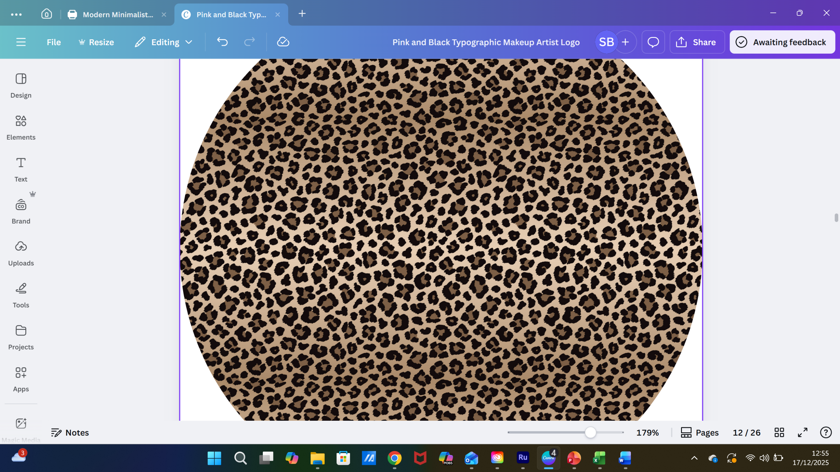
Coleg Y Cymoedd. Level 3 UAL Extended Diploma. Tv & Film, Hair, Make-up, and Special Effects - Distinction
References available on request.
GDPR: I consent to my details being kept on file and being distributed for employment reasons.

